# Exercise 9

Following is the higher-level SIMULINK model of the QUBE Servo 2.0 DC motor.

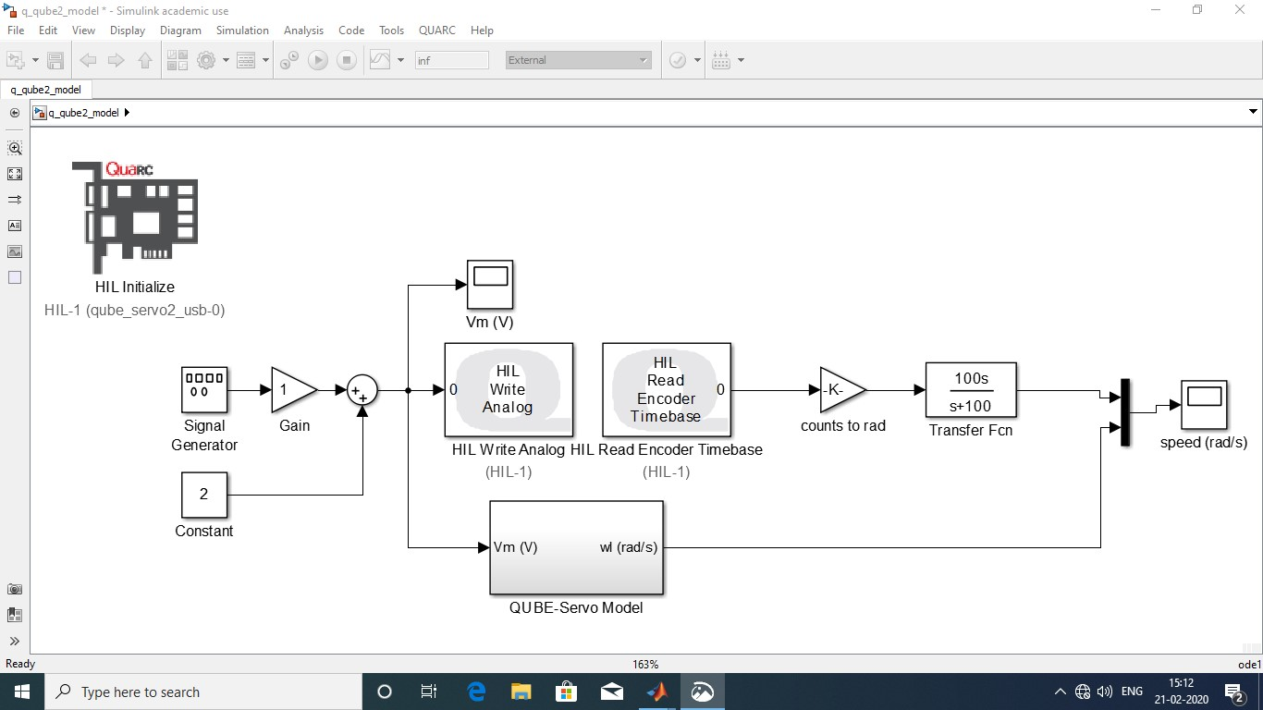

Low pass filter

Figure . Higher level SIMULINK model

Following is the detailed SIMULINK model of the QUBE Servo 2.0 DC motor derived based on the equations stated in the exercise record.

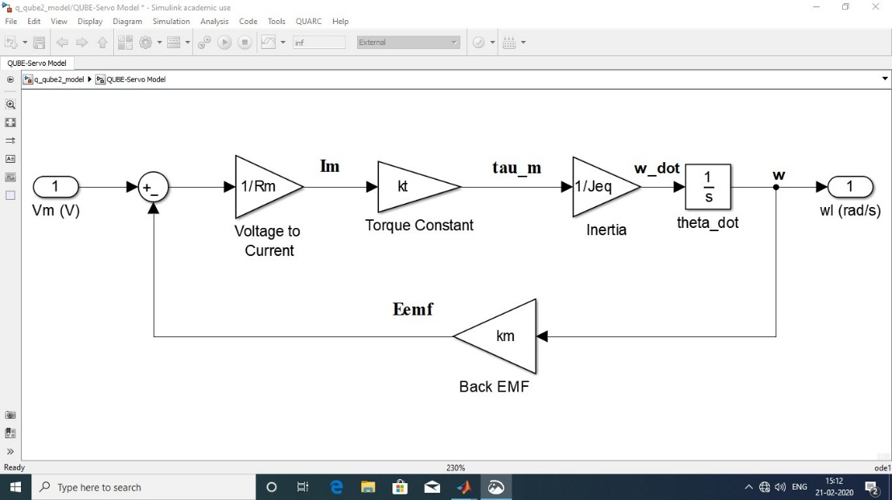

Figure . Detailed SIMULINK model

Following is the MATLAB workspace (and script) that hosts the necessary variables for system parameters.

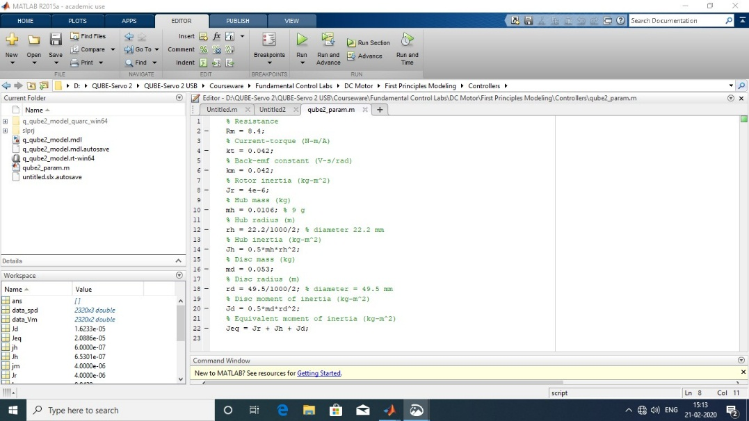

Figure . MATLAB workspace and script

Following is the multiplexed (combined) output of the derived model and real time output of the QUBE Servo 2.0 DC motor.

A step input of unit amplitude (A = 1) and frequency of 0.4 Hertz (f = 0.4 Hz) was applied to the system model as well as to the real hardware (QUBE Servo 2.0 DC motor hardware) and the output from both was multiplexed and fed to a scope in SIMULINK.

The output as displayed in the scope is shown in the following figure indicating the input applied to the first principles model and real system as well as the output of (observed from) the model and the real system.

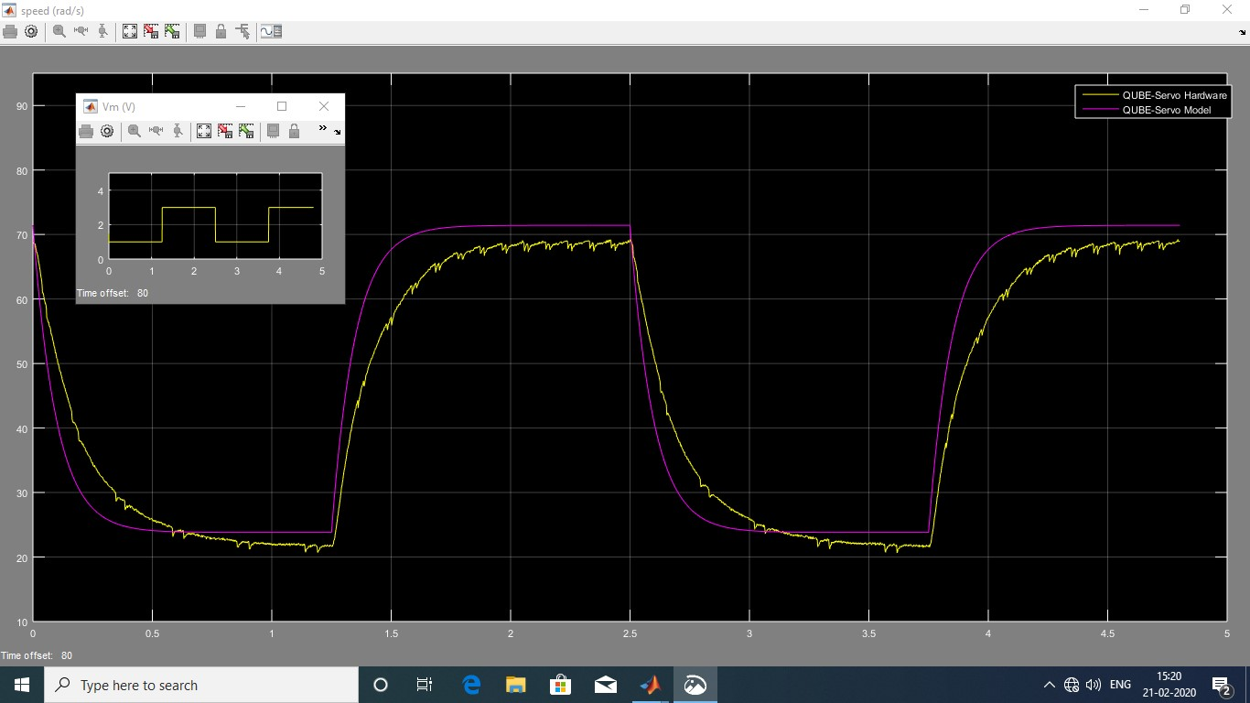

OUTPUT

STEP INPUT

Figure . Output

In the above figure, the purple colour plot is the output of the first principles model whereas the yellow coloured plot is the real-time output of the QUBE Servo 2.0 DC motor hardware.

Since measurement (sensor – encoder in this case) of physical systems always involves noise/disturbances, a low pass filter (LPF) was introduced so as to minimize the high frequency noise and increase the signal to noise ratio.

However, despite the presence of the low pass filter in the high-level SIMULINK model, there was a little noise observed in the real-time output of the QUBE Servo 2.0 DC motor hardware. Thus, some amount of rough profile can be observed in the plot of real-time output of the QUBE Servo 2.0 DC motor hardware.

Since both the plots lie quite close (i.e. the real-time output of the actual physical system and that of the derived model are almost equal) it can be inferred that the first principles model (model derived based on the set of equations governing the dynamics of the system) is quite accurate (though not very accurate).

Thus, it can be concluded that since the output of the derived first principles model and the real-time output (output of the physical system) are very similar, the model is a pretty good representation of the QUBE Servo 2.0 DC motor hardware.